Level 0 – Rainy hall
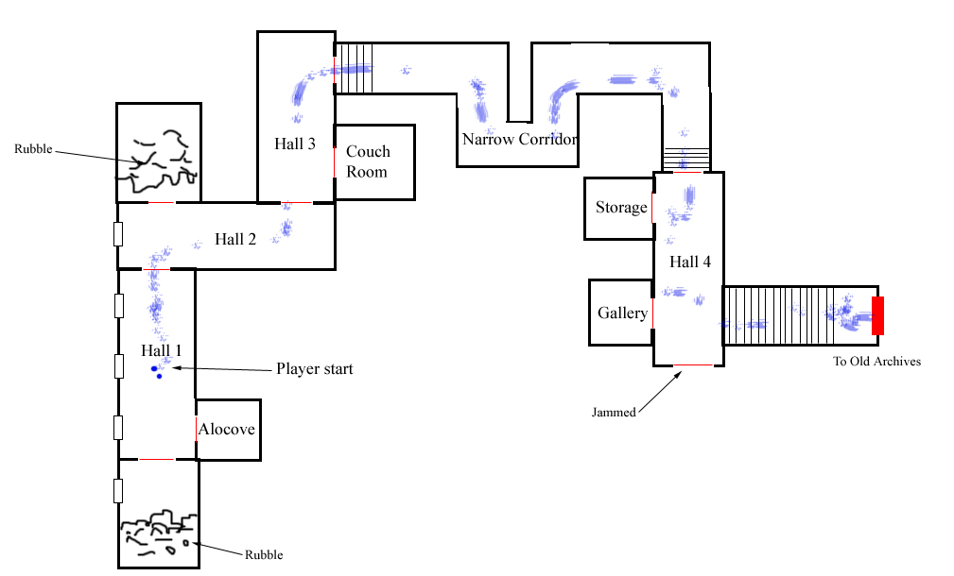

Overview
The player wakes up dazzled and confused a hallway. A rumbling sound is heard in a distance for few seconds before fading out. Dim light shines through the windows and the sound of rain pattering on glass is heard. Every now and there is a sound of a breeze rushing through, but apart from that and the sound of rain it is dead quiet.
Beside the player is a broken bottle is found and a trail of blue liquid leads of to the north.

Following the trail will take the player to Old archives and during this walk a sense of dread is built up.

Rooms
Hall 1
Where the player wakes up. The sound of rain pattering the windows is heard. Dim rays of light are cast from a row of windows. Along the walls are some cabinets and small paintings.

Alcove
A small room with a lit only a lit candle on a table and a chair.

Hall 2
The sound of rain is still strong. A single window cast dim rays of light.

Hall 3
There are some cabinets and paintings here. It is illuminated by lights on the walls. The sound of rain has gone more silent here.

Couch room
Three comfy chairs are placed around a round table. In a corner stands a chandelier and emits light over the room.

Narrow corridor
The walls are closing in here and gives the player a compressed and claustrophobic feel. Creaking sounds are hard from the ceiling, as if it was coming apart. The sound of rain has gone almost completely silent. Some lights on the walls help cast a gloomy light over the scene.

Hall 4
Is a bit brighter than the narrow corridor. A cabinet and some chairs have been tipped over here and there are also large amounts of blue liquid stains. Daniel stumbled around here quite pit spilling from the bottle and hitting furniture.

Storage
Three selves are on the shelves but apart from some stray book and bottle there is nothing in them. Light from hall flows in.

Gallery
Some small painting are lined along the walls. In one corner is a chair and in another is a lit chandelier.

Events
Door slams op
When the player steps in to hall 3, the door into couch room slams open by a gush of wind.

Footsteps
Entering narrow corridor, faint running footsteps are heard at the end of it.

Door slow open
When entering hall 4 the door to gallery slowly slides up with a creaking noise.

Level 1 – Old Archives
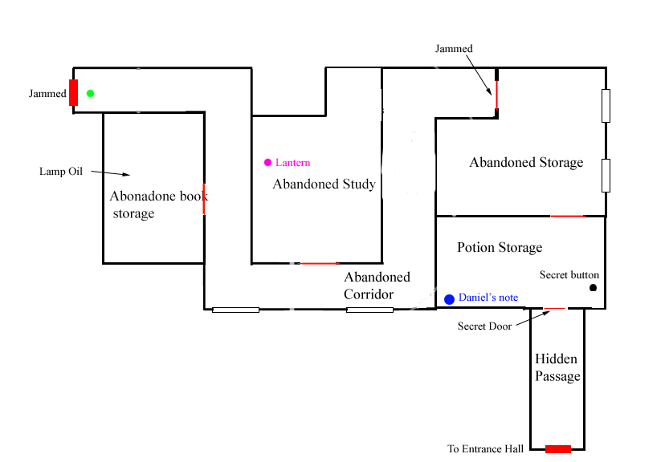

Overview
When player enters the old archives it is lit by torches along walls. Having traveled around the first bend a rumbling sound is heard, the screen shakes and the lights go out. The player is now trapped in the darkness and needs to find a source of light and a way out.
A faint echo of window blowing rain can be heard near the west, but this tones out as the light goes out and ambient track takes over.

Notes
Daniel’s Note
A note that Daniel has written to himself before taking the amnesia potion. The says that he took the potion because of thing that have happened. It then continues that something is hunting him and that he must find his way to the tomb. His diary must be something and if he finds it, it will explain everything.

Events
Cockroaches
When the player is in the middle of book storage he has a brief vision where cockroaches appear.

Darkness
When the player has reached the first bend in the corridor, a thump is heard and then the light goes out. The levels is now in darkness and an ambient track fades in.

Door opens
When both the lantern and lamp oil in book storage is picked up, the door to the storage opens and a loud creaking sound is heard.

Puzzles
Light candles
Once lights go out the player needs (or is encouraged to) light lights in the lamp with tinderboxes. These lights should not illuminate too much though, and the level should still be quite gloomy.

Find secret button
There is a shelf that can be swung open, behind it there is a lever that when pulled will swing another shelf open and behind it a secret door in the wall will open.

Rooms
Abandoned Corridor
This part used to contain books long ago, but when the archive was expanded to the east then this was no longer used. Books are scattered on the floor and some old chandelier hangs in the ceiling but apart from that the corridor is mostly empty. The walls are old and dirty stone walls and belongs to the older parts of the castle. Two windows flood the corridor with sharp light and act as the only source of light. The connected rooms are mostly in darkness though.

There can be heard some low thumping noises from the walls, like if something was crawling in them and the door to a room will swing open seemingly by itself.

Abandoned Book Storage
Like the corridor most of this has been moved to other parts of the archives. There some empty shelves here and some boxes in a corner. From one corner there is some strange thumping coming and if the player goes near it the door to the room is slammed shut.

Lamp oil can be found on a shelf here.

Abandoned Study
An old table and chair once served as a work desk. There is also shelf containing some old books and on the floor papers and the remaining books lie scattered. The window have had boards put up in front of it and only a few rays slip through and helps little to illuminate the room. A hole in the ceiling sends down faint rays of light illumination.

The lantern can be found here.

A large thump will make the shelf shake and the books will fall off it.

Abandoned Storage
Various equipment was stored here once but then later on moved to either the archive cellar or the new archives. Now here are just some old shelves and boxes here illuminated by faint light coming from the windows.

Potion Storage
The shelves are lined with potions and a table is filled with chemical equipment. On the floor lie a lot of scattered broken bottles and large puddles on various liquids. The light here is quite dim and most of the light comes from the room next door.

I was here that Daniel wrote a note to himself and drank the amnesia potion.

Level 2 – Entrance hall
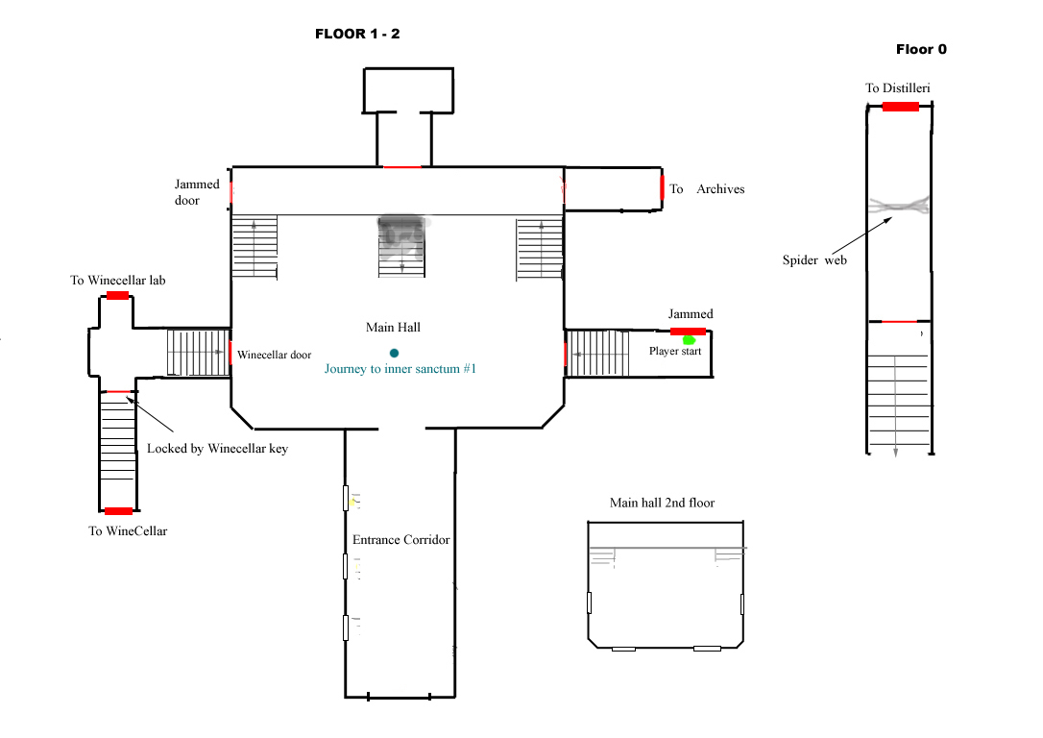

Overview
The player now enters a large hall with plenty of doors leading of to other parts of the castle. All of the rooms that can be explored from here leads off to dead ends except for a the Wine Distillery which takes the player further into the castle. The path leading to this part is blocked by slimy web though and needs to be destroyed by an acid potion. Creating this potion will be the main quest for this part of the castle.

Visions
Journey to Inner Sanctum #1
Daniel asks Alexander where they are going and he answers that they are going to the Inner sanctum and must pass through distillery to get there. As vision is played a faint trail of particle smoke appears and shows the path down to distillery.

Quests
Find Wine cellar key
When player has checked the door leading to wine cellar and found it locked this quest is given. When unlocked the quest is completed.

Destroy web
When the player is close to the slimy web then this quest is given. When the web is destroyed by the acid potion than this quest is completed.

Events
Howling 1
When the key has been found in the archives and the player enters the hall a faint and distant howling is heard and some slime appear on the walls.

Howling 2
When the player has collected all of the chemicals in the wine cellar a louder howl is heard and more slime is present in the hall.

Howling 3
When the acid potion is completed there is a howl that sounds very near and the hall has been filled with quite a lot of slime.

Level 3 – Archives
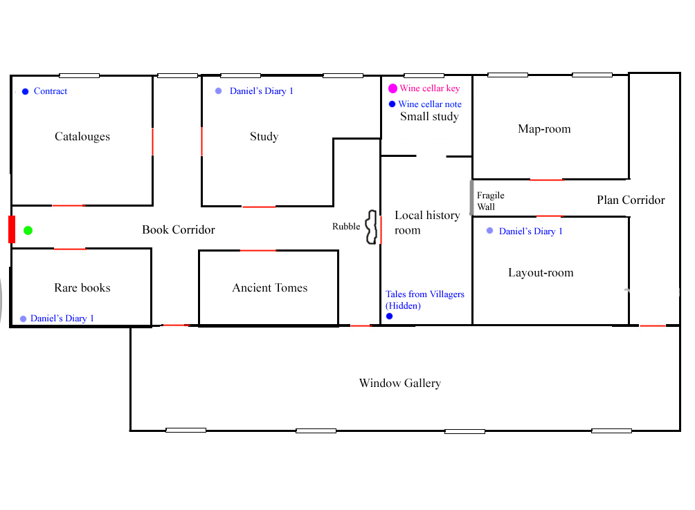

Overview
Here is where most of the historical documents are stored and it also contains blue prints for the castle. The player can learn the location of the castle as well other similar information here.

The player needs to find a hidden room where a the key leading to the wine cellar is found. Inside the room a note also explains why a key to the wine cellar is hidden here.

Notes
Tales from Villagers.
An overview of stories told by the villagers about strange happenings in the castle for the past 400 years or so.

Daniel’s Diary 1
Daniel tells the tale about the dig in Africa. Final entry is how he goes home.

Wine cellar note
Short note from the Alexander saying that due to an “incident” the wine cellar it must now be kept locked.

Contract
A brief contract that vaguely states that a man (the one who wrote the transformation) that their job will be to kidnap two people and bring them to the castle.

Visions
Tomb
As the player picks up the third piece of Daniel’s Diary 3 he is teleported to a black room with only his lantern as light (player is given oil if below 50% and torch is automatically turned on). The player will walk towards a blur light at the end of the dark only being able to see the floor and cannot walk back or to far left or right (invisible wall or just speed reduction). The players speed is reduced and his view and such should match the narration heard from his diary. As he comes close to the light it is revealed to be a free floating orbing and upon toching it the screen goes black, a sound of the orb shattering is heard and the vision ends.

Items
Wine cellar key. The key that opens a door a door leading to the wine cellar.

Puzzles
Enter Local History room
The door leading in here is blocked by shelves and other furniture. In order to get in here the player needs to destroy the fragile wall in the Plan Corridor by throwing some object at it. The fragile door should look very different from the normal mansion walls.

Open secret room
The player needs to move three secret books within a certain timeframe in order to open the secret door to Small Study. This mechanism in hinted in the historian’s diaries.

Rooms
Book Corridor
This is the new part of the archives and was built a little over 200 years ago with the purpose of the storing the ever growing pile of documents, mostly consisting of plans outlaying the expansion of the castle. Cobwebs and dust is ever present but the furniture is newer and in better shape. One single window cast a gloomy rays and gives the corridor a dark ambience. Scratching noises can be heard at some places in the ceiling followed by dust falling down.

Catalogues
Shelves containing papers are lined up against the walls. A desk overflows with paper piles and the floor is also covered with them. This room was used for keeping track of where books where placed but no system was ever used making the room a random mess of papers which does not serve its original purpose. On the table there is only one clean spot and here a note about the building of the new archives is found.

Rare books
This room has been used to store some of the more rare books that the Alexander had collected over years but these have been moved to other sections of the castle. Some books are left on the shelves and some litter the floor together with scraps of paper. Light flowing from a hole in ceiling helps brighten the room and also makes a diary visible.

Study
Compared to the other rooms connected to the Book Corridor this room is pretty tidy with clean work desk and books coherently aligned on the shelves. The rooms is also quite well-lit because of the two windows in it. Along the walls shelves are aligned and at the windows there is a work desk with some books piles, pens and papers.

As the player enters the sound of scratching is increased and as it is about to reach its crescendo a shelf is slammed open with a big and books fly out over the room. After that event the scratching stops abruptly.

Ancient Tomes
Large and thick books are placed on the shelves and where left here mainly because they where too heavy to move. There is a small desk where books lay open and a note lies next to it. A blown out candle also stand next to it and apparently someone has been translating texts from the old tome here. Almost no light shines in here and it as good as pitch black except from the light coming from the corridor.
As the player enter the room a large book falls from one of the shelves and some scratching is heard from behind the walls.

Local History Room
Two paintings depicting humans rising from their graves hang on the walls and shelves along the walls are overflowing with books. Light from the small study next to the room illuminate and makes the room quite well lit.

Small study
This room lies next to the local history room and acts as an extension to that area. The room is bright because of the window taking up most of the northern wall, making the mess in the room clearly visible. Shelves lie on the ground tipped over, paper notes lie scattered all over and books are randomly spread out. There is a work desk next to the window but it is hard to see because of all the rubble.

Window gallery
Bright light coming from the large windows flood the room. There are curtains at the windows swaying gentle from some unidentifiable breeze and on the walls hang pictures. By the windows a some chairs a placed seemingly without any order. This room was room was meant to exhibit to relax in, but instead invokes a silent dread, like the silence before the storm.

Plan Corridor
This corridor connects to the rooms where all of the planning from the construction of the castle is stored. It also marks the end of recent archive area and has an increase in cobwebs and dust floating about.

Layout Room
On the wall hangs three pictures showing the castle at various stages and showing how it has grown over the years. The room also a desk filled with paper stacks and shelves with some books and paper rolls. Most of the room’s light comes from a hole in the ceiling filled with spider webs.

Map Room
A map over Europe from around 1300 hangs on the wall together with a map over Prussia from 1400. Along the walls are shelves containing rolls of paper, stacks of paper and books. One of the windows illuminating the room has boards over it and only emits thin and faint rays while bright light streams from the other.

Level 4 – Wine cellar lab
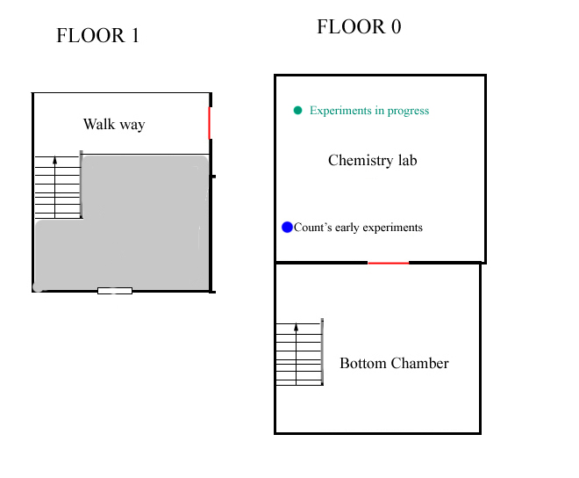

Overview
Contains the equipment needed to create the acid potion.

Notes
Alexander’s early experiments
A shirt note where the Alexander describes some experiment he have been made from some “recently required knowledge”. He is trying to make a strong potion that will be useful for some otherworldly things and notes that the following substances are needed:
Aqua Regia, Calamine, Cuprite and Orpiment.

Visions
Experiments in progress
Sounds are heard of glass clanking, water boiling and fires burning. The Alexander is mumbling strange formulas in some unknown language.

Quests
Find chemicals
If the player operates the acid potion without having poured in the chemicals this quest is given. It is completed when all 4 chemicals have been poured into the machine.

Puzzles
Create Acid Potion. In the chemistry lab there is a machine with 4 bottles with valves connected to it. In order to create the acid the player needs to:
1) Pour the 4 chemicals into the containers.
2) Turn a valve and turn on the burners. (this is not really 13th century stuff, but have to live with that?)
3) Put the chemical container below the tap (it snaps in place).
4) Turn the valves above the machine containers in a specific order
Turn on A, Turn on B, Turn off A, Turn On C, etc until D is on. Then liquid will pour from the tap. The way it works is that all bottles except A needs the one before it to be on before it can be on and if 3 or more are on, then all are turned off.
When bottle’s valve is on then it bubbles a little and when it is really on it bubbles a lot and steam pours out.
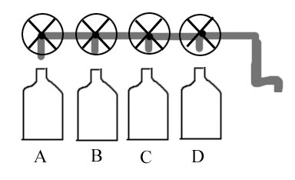
Note: The pipe from bottle D should be the only leading to the tap. So that one notices that D must be really on for the acid to be created!

Rooms

Walkway
A wooden walkway with a staircase leading down to lowest levels of the basement. The light coming through the window is the last seen on the way down to the bottom of the wine cellar.

Bottom Chamber
There are no light sources here and the all the rooms have a dark blue tone. The ground is made from dirt and a thick fog swirls around. Creaking is heard from the floor above and dust falls through the cracks of the wooden ceiling.
This first room of the bottom room is void of any object except some old chairs and shelves.

Chemistry Lab
A very primitive alchemy laboratory with some simple chemistry equipment at an old desk, a shelf with some remains of the chemical bottles and a special acid creating machine. Some alchemy posters are put on the walls and from a grating in the floor thick smoke pours out.

Level 5 – Wine cellar

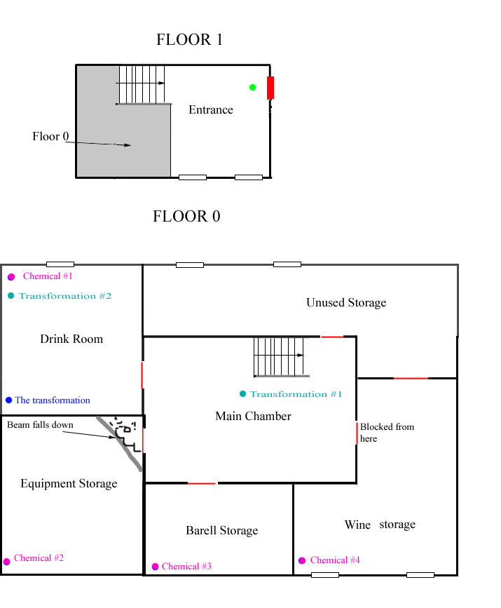

Overview
The chemicals needed are spread out in the rooms and player will hear the presence of servants here. This level is mostly an ambient piece and introduces the sounds of the servants.

Visions
Transformation #1
Willhelm and his friends talk how nice the Alexander has been to invite them in for wine. (this is heard when player has descended the stairs and steps on the floor)

Transformation #2
Sound of screams are heard as the thugs are transformed into the servants. This is when Willhelm writes down his last notes.

Notes
The transformation
It is an old note from early 17th century. Willhelm, a noble man, describes how he and two friends had for many years been doing business with the Alexander and to “find suitable humans and animals” (ie find torture victims). He said that they had helped him many years now and that Alexander had invited them to the castle to give them and extra large reward. They had been given wine and drunk quite a lot in the cellar when something suddenly started happening to them. The man remarks how the wine had tasted funny and how he saw that his friends and himself started to change: bones growing in strange and muscle crawling around. He says that his companions have already fainted from the terrible pain and that he must write down the events. The note ends in the middle of a sentence.

Events
Bang on door. When the player is close to the door leading to the drink room a muffled scream and three loud bangs are heard on the door.

Creaking noise. Creaking noises are heard from the floor above and low mumblings / groans are heard too. It is supposed to suggest that something else is walking about here.

Beam collapse. Entering the equipment storage a beam collapses and falls down from the ceiling together with a bunch or rocks. The door to the room gets closed and the player needs to move some rubble out of the way in order to exit.

Steps. When the player enters winestorage some quite steps are heard from the unused storage together with some grunts. The sound of a bottle breaking is heard and the steps fade out.

Items
Bottle of Aqua Regia
Bottle of Calamine
Bottle of Cuprite
Bottle of Orpiment

Rooms
Entrance
Two windows cast light on the wooden staircase that leads down to the cellar. There is not much here except some boxes in a corner. The floor is made out of wooden boards and next to the stairs is a railing where one can see the cellar from.

Main Chamber
All of the rooms on this floor have wooden boards and light comes from the few windows scattered through the rooms. This main chamber lies empty except for some stray bottles and dried up pools of wine. Light coming from upstairs sheds brightness in the area.
Moaning and strange footsteps are heard from the floor below.

Drink Room
Two tables with bottles, glasses and unlit candles are thrown out over the table. On the walls hang various paintings to lighten up the atmosphere. There are stains from wine on the table, floor and walls and rays from a windows casts light on the scene.
This is also where the Alexander locked up three men and transformed (let their bodies be hosts) them into servants. The floor and walls are filled with blood splatters from this process.

Unused Storage Room
This is where the burglars broke in a few centuries ago and one of the windows being boarded up is evidence of this. From the unbroken window lights help illuminating the boxes scattered over the floor and the empty shelves along the walls. This was meant to store more wine but after a while the members of the brotherhood got bored with the wine and abandoned it.

Wine Storage
The shelves along the walls are filled with wine bottles. This is where most of the wines are stored and the shelves are filled to the brim. Plenty of light flow from the two windows making the room the brightest in the wine cellar.

Barrel Storage
This where wine barrels are made and store. Barrels are stacked against the walls and on the floor lay debris from unfinished ones. The room is dark and gloomy and has no light sources.

Equipment Storage
Various equipment is still stored here and most of it is packed into boxes stacked into shelves along the walls.

Level 6 – Distillery
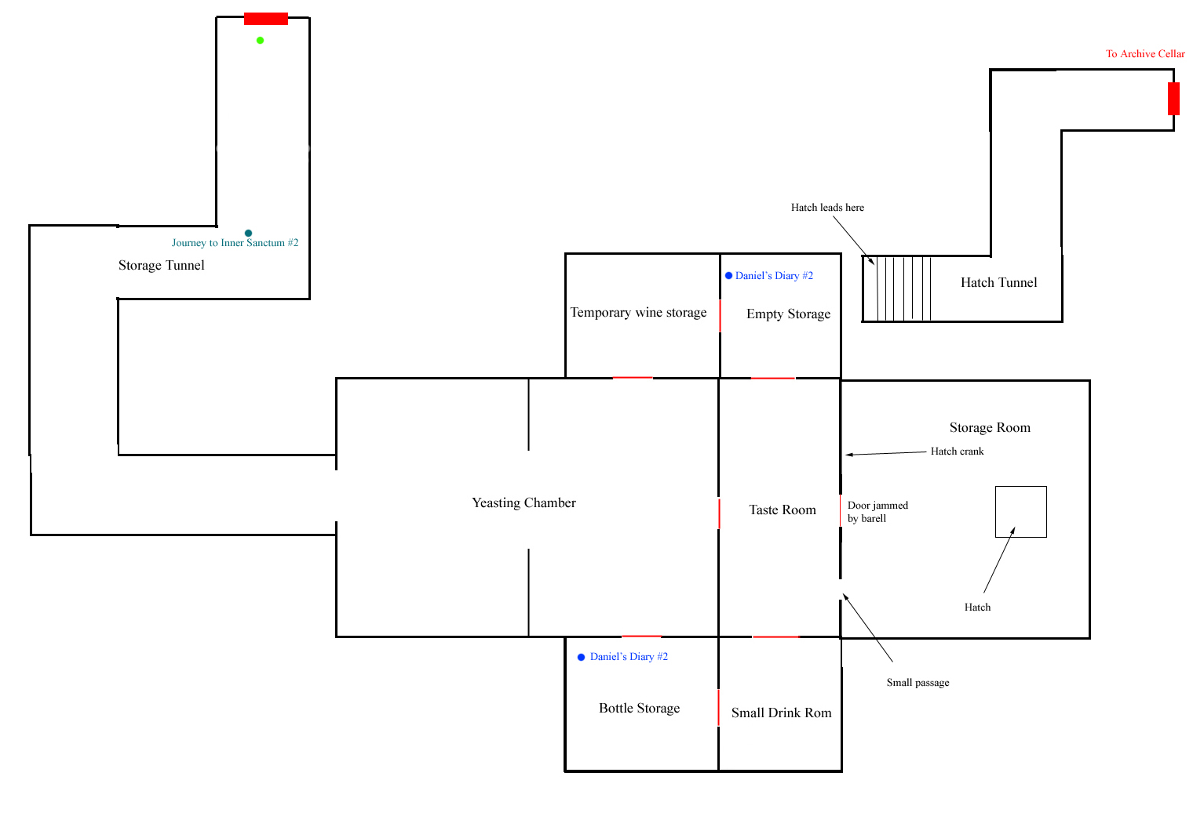

Overview
In this level the sound of the howl come in short and increasingly louder bursts as the player nears the end of the map. The level also have bits and pieces of slime on the walls.

This map also has some short enAlexanderers with the servants and all shall be easy to avoid.

Notes
Daniel’s Diary 2
Daniel comes home from Africa. This is about his first tests with the stones pieces. It ends with him discovering that they seemed to be changing and cannot figure out why that is so, he drops further research.

Visions
Journey to Inner Sanctum #2
Daniel wonders why it is so dark here and Alexander gives a vague and ominous reply. Alexander also says that they must continue further in and further down for quite a bit. A faint trail of smoke shows the way during the visions.

Puzzles
Blocked door
The door leading into the storage room is blocked by a barrel. The player needs to push aside some funk in the taste room to find a small passage that leads in south of the door.

Open hatch
There is a rope attached the hatch and by some pulleys in the ceiling it leads to a crank. By turning this crank the hatch can be opened, but when the player tries it is stuck. By checking the pulleys it can be noticed that a chunk of wood is blocking one and by throwing something at it, the wood will break and the hatch can be opened.

Events
Glimpse of grunt. As the player enters the yeasting chamber, a grunt walks by at the end of the room and the player should only be able to catch a short glimpse of the creature.

Random moans. After the glimpse of the grunt, random moaning and scratching sounds are heard in the map.

Empty storage door opens. When the player is in the northern part of the empty storage, a moaning is heard and the room’s southern door opens, but there is nothing behind it. If the door is already open, then nothing happens and the event lies dormant until the door is closed.

Wall scratching. When in the bottle room, something starts scratching on the northern door while panting for a few seconds.

Howling
There are three howling hear here, each louder than the previous. The first after exiting

Rooms
General
The rooms has slime here and there and the amount increases the further to the east the room is.

Storage Tunnel
Here lie some tools and scattered planks, the rest of the tunnel is pretty bare of any objects apart from rock and wooden debris. It is also very moist here and water drips from the ceiling and pools of water is scattered throughout the tunnel.

Yeasting Chamber
Very large wooden barrels are placed along the walls. The rooms also has wine stains all over and some unlit torches placed randomly.

Temporary Wine Storage
A few bottles and barrels that did not fit on the floor above are placed here.

Taste Room
This is where wine from the yeasting is tasted. A large table with glasses, bottles and unlit candles is located in the middle of the room. Old wooden chairs are thrown around and there pools of wine on the floor. A crack in the ceiling above the table casts the only source of light on this floor.

Empty Storage
Apart from one empty shelf and a few wine stains, this room is void of content.

Small Drink Room
A small table with some bottles is the centerpiece of the room. There is shelf with some bottles and a chair stands alone in the corner.

Bottle Storage
Along the walls are shelves with empty bottles to be filled up with wine from the yeasting chamber. There is also some barrels in here.

Storage Room
A few boxes are scattered around in the room. There is also some old shelves along the walls, but the room is mostly empty. There is a vague red glow in this room and a more intense red coming from the tunnel.

Hatch Tunnel
Apart from filth from on the ground, the tunnel does not have any objects. However, it has the largest concentration of slime of all rooms in the map. The tunnel is a colored by intense red coloring coming from an unknown source.

Level 7 – Archives Cellar
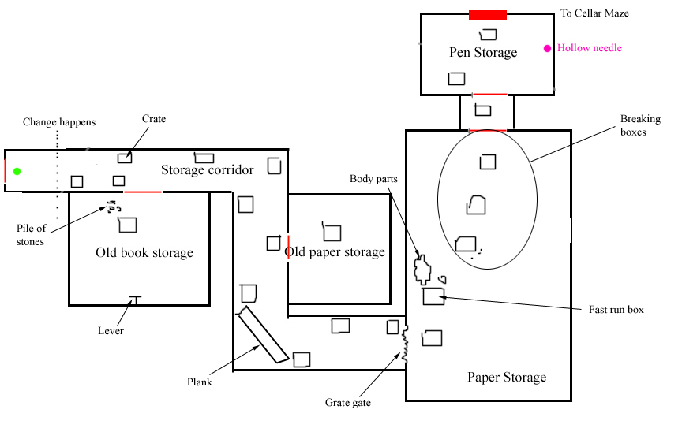

Overview
When the player enters the cellar is normal but then after having walked for a few meters everything goes black for a 2 – 3 seconds and loud howl is heard. It then fades in quickly again and the environment has changed. There are slime all over and 3 - 4 dm of water. The door back has been covered by slime and cannot be opened. The player is now in the guardian’s realm and must find the door out.

There is something moving around in the water and attacking the player. The puzzle is for the player to stay out of the water. This is done by jumping on crates and other larger objects in the water.

Puzzles
Plank
The player must push a plank down in order to reach the next box.

Open Grate gate
In order to open the gate leading into the paper storage, the player must pull the lever in Old book storage by throwing a rock at it (or running quickly in the water). The grate gate will then open but also slowly close so the player needs to hurry to get through.

Run for life
To reach the box between paper and pen storage the player must pick up a body part and then throw it into the south east corner. The creature will then munch on it for a few seconds, giving the player time make a run for it.

Open door to maze
The door leading to the maze is locked “by a simple lock”. This can be opened by using the hollow needle on it. The needle is found in a cabinet by one of the walls.

Events
World transformation
When the player reaches the “Change happens” line, the screen suddenly goes black, a loud howling is heard and then the screen quickly fades in again showing the changed world.
Practically this is done by having a normal version of the first half of storage corridor that he player start in and then teleport the player to the proper map.

First Attack
After being teleported to the new map, after 3 seconds a large splash is seen at the first bend in storage corridor and then a creature (visible only by splashes on the water surface) rushes toward the player. The player must jump up on a box to avoid the monster and from this moment on, touching the water means getting attacked.

Box breaking
When the player is on the box before the “fast run box”, the “breaking boxes” are destroyed one by one. This cuts of the players path and he needs to find another way around.

Rooms
General
Once the level has transformed all of the rooms are filled with 3 -4 dm of water. At places water is flowing along the walls and in some places there are water dripping in the wrong direction (down to up).
All over there is plenty of slime and fog. The whole level has a red/brown glow to it.

Storage Corridor
This corridor belongs to an older part of the castle and was once a book-storage and archive together with the rooms in the abandoned corridor. Now that the new archive has been built most of the rooms have been emptied while some act as storage for writing material. This part of the archives is very dark, almost pitch black and void of light sources.

Old Book storage
Shelves and some old books on the floor hint that this used to be a book storage.

Old paper storage
Like the books storage this room is also covered in webs but here carcasses and bones cover the ground.

Paper Storage
Apart from some pillars and shelves there is not much in this room. Pillars are lined in two rows.

Pen storage
Some shelves with boxes lean against the walls and on a table a bunch of goose pen are standing.

Level 8 – Cellar maze
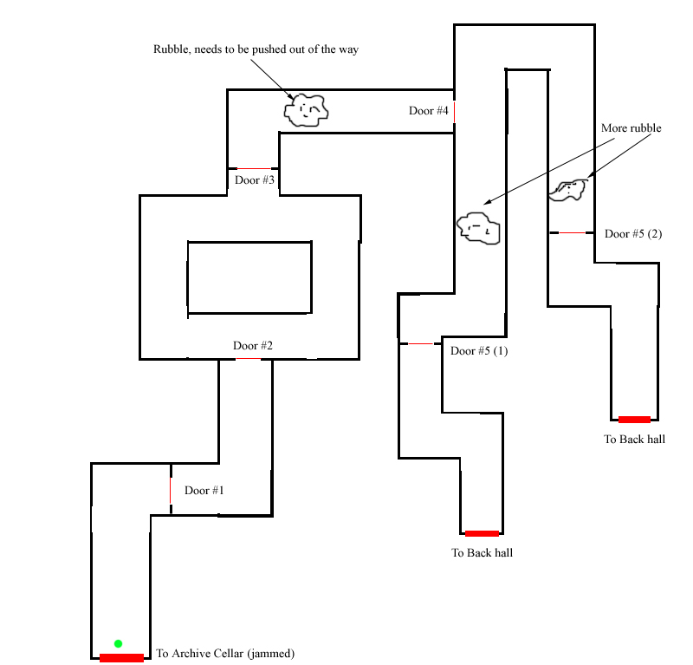

Overview
After getting out of archive cellar, the player is in yet another water filled map with slime. As the player has walked in a bit a large roar is heard from behind. The player must now close a door and then run for the exit. The doors will be broken by a changing creature but the player will only be able to day at the start. The after closing the first two doors there is no risk of dying. But the player must still close another 3 doors the creature seemingly getting closer and closer.

Having the found the exit, the player will emerge in back hall.

Events
Attack 1
When the player is near door #1 a low howl is heard and a the create from Archive Cellar starts chasing him. The player now has to door #1 after which the create starts pounding on the door.
The player now has a few seconds to reach door #2 and close it before the create breaks through door #1
Once door #2 is closed, the creature will be far less aggressive and it will be hard to die.

Attack 2
The creature continues pounding on Door #2 until the player is near door #2 after which it breaks through. The same happens for door #4.

Attack 3
The pound on door #5 starts very soon after it has been closed and will be destroyed very soon after. The player now just needs to run as fast possible to reach the door leading to back hall.

Rooms
General
The level consists of stone walls covered in slime and its floor has 3 – 4dm of water. Red ambient light is scattered throughout the level.

Level 9 – Back Hall
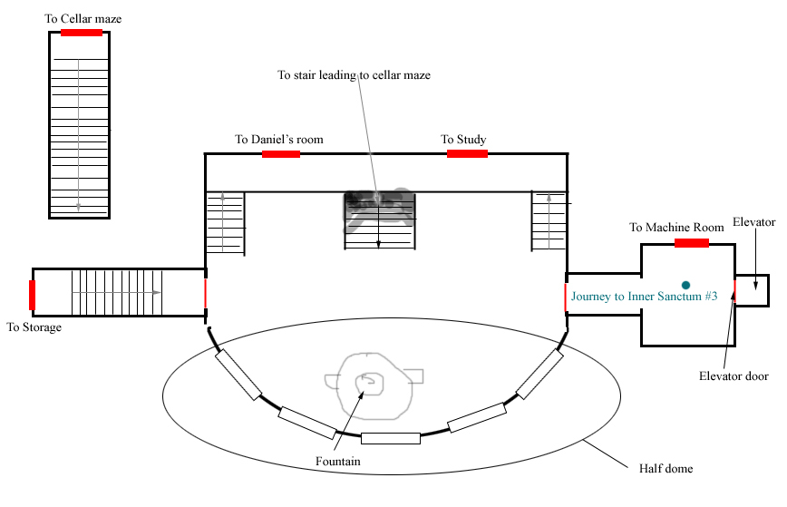

Overview
This hall is smaller than the Entrance hall and a bit dimmer. It leads to the Daniel’s room, storage and machine room, Daniel’s room and study. There is an elevator here leading to the dungeon but it is not working and needs to be fixed.

At first the hall is clean but once the machine is finished a lot of slime has been added and the howling is heard from around.

When the machine is fixed the door into the elevator is fixed.

Visions
Journey to Inner Sanctum #3
Alexander explains that they must now ride an elevator to get further down. A faint trail of smoke shows the way during the vision.

Events
Guardian is near
When the player has the machine instructions (from study) and machine parts (from storage) then the fountain water turns red and howling is heard not far of.

Howling gets loud
When the player has fixed the machine in machine room, there is howl and the screen shakes. Blood begins to drip from the ceiling too.

Level 10 – Daniel’s Room
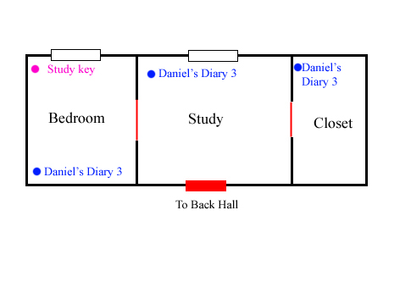

Overview
This is a small map of Daniel’s room where all furniture is scattered about and it is pretty much a mess. When the player enters here he will hear the voice of Daniel saying things like “Oh, so I am supposed to sleep here”, “It has returned, the howling, it is back”, etc.
The Study key is hidden here.

Items
Study key

Notes
Daniel’s Diary 3
Daniel receives the professor’s diary that he very briefly summarizes (will be found later on), he starts tampering with he pieces and manages to put them together. He also talks about the Alexander a bit. The entries end with him feeling on the orb noticing its force.

Puzzles
Find study key
Behind a painting the player will find a hiding space where there is a bottle. If the player destroys the bottle the study key will fall out.

Events
Voices
There are voices heard in the players head as he enters the map. They come a X seconds after each in the following order (texts are drafts):
“So this is my room…”
”The howling, it is back…”
”I must hide the study key somewhere…”
”They have searched the room, the book is gone…”
These represent thoughts that Daniel has had earlier.

Rooms
General
The Alexander’s servants have been searching the room and have turned it upside down. Furniture is broken and scattered around the room.

Bedroom
Close the western wall there is large bed. Bright light and flow from the window and illuminate the dust circling.

Study
By the window is a work desk and streams of light flowing from outside. The room is quite bright and filled with dust particles.

Closet
There is no window in this room making it much gloomier than the other. There are cabinets by all walls except the western. The floor is filled with scattered old rags.

Level 11 – Study
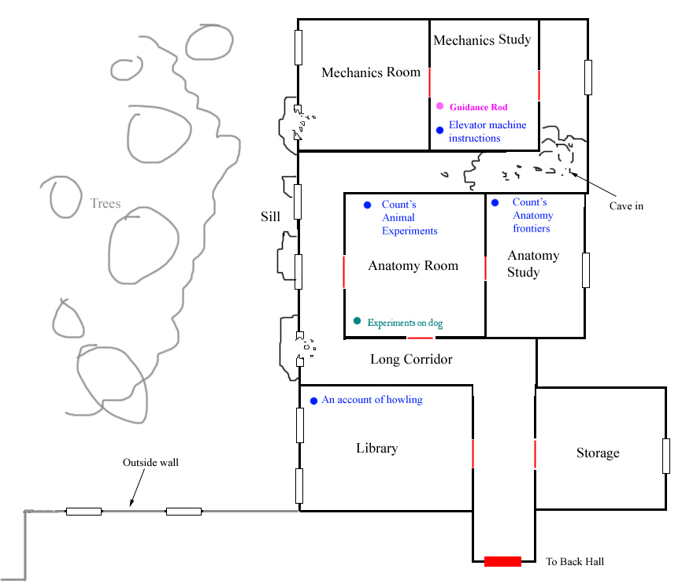

Overview
The rooms was the where the Alexander made some of his studies. Some of the books here describe the orb and rituals around it. This is a very calm map and there should not be much shock events, instead it should give the player a break and build the atmosphere by supplying scary texts to read.
At the back room the note describing the elevator engine can be found.

Notes
Elevator machine instructions
Describes how the engine that powers the elevator works. The important details are:
- The guiding rods are used to control different things. First rod controls the trinity steam set of functions. Second controls the amplitude. The third completes the cycle of steam flow.
- The upward flow must have 7 units of power and then downward 8.

An account of howling
The 17th century account of a munk who has been near an orb and is now followed by the guardian and describes the sounds heard and is caught inside the guardian (just as player was) and manages to escape. Two of his fellow munks that also touched the orb does not managed to escape and the survivor describes their gruemsome faiths. However it is gaining on him again and seems to be growing stronger. His last notes reAlexander how the environment changes around him.

Alexander’s animal experiments
Old document (16xx?). The Alexander does some experiments on animals trying to work out how the brain and body works.

Alexander’s anatomy frontiers
Old document (16xx?). The Alexander briefly states that reading books is not enough and that living tissue will be needed to make advances.

Items
Guidance rod. One rod that is used in the machine room (rest are in level 12).

Visions
Experiment on dog
An experiment is made on a living dog where it’s head is cut off. The dog is heard giving off a gurgling howl which turns into a silent yelp as it life is drained away. During the whole procedure it heard how the Alexander is sawing through the dogs throat.

Puzzles
Get to mechanics room
To get past the cave in and into the mechanics room the player must go out of the broken window in the long corridor and then jump on the broken sill to reach the next window. It should not be completely obvious that there is a sill outside of the window that the player can stand on.

Events
Howl
When the player has gone a few meters north on the sill a not too distant, and now familiar, howl is heard.

Rooms
General
The level is well lit and have a feel similar to that of the Archive level.

Long corridor
Apart from two lone cabinets and carpets on the floor, the hall is empty. A heavy draft blows from the broken window and the western windows scatter light throughout the hall.

Library
The shelves in here are stacked with books and the plenty of piles and scattered books are on the floor too. Moonlight flow through the window.

Storage
Stacks of paper and boxes crowd the shelves along the walls. The lone window shine rays of light illuminating the mess.

Anatomy room
The walls are filled with anatomy drawings and on tables stand plenty of stuffed animals. Some cutting instruments lie around and there are a few dried in bloodstains on the ground. Plenty of lights are placed on the tables giving the room a shrine like feel.

Anatomy study
More sketches cover the walls here but there are no stuffed animals. By the window is a work desk and along one wall stand a shelf packed with books. Light flow in from the window and illuminates the room.

Sill
It is barely that the player can stand on the badly battered sill. There is a thick mist outside and there is a hint of tree tops further away, the mist conceals any objects further away though.

Mechanics room
The room is badly damaged and there is a thick fog on the ground. Walls are covered with sketches of various contraptions and blur prints and shelf contain many scrolls of drawings. The floor is littered with papers and chairs and smaller shelf has been thrown around.

Mechanics study
Except for a workbench the room is fairly empty. On the workbench lie the elevator machine instructions. A lone candle barely lights up the otherwise dim room.

Level 12 – Storage
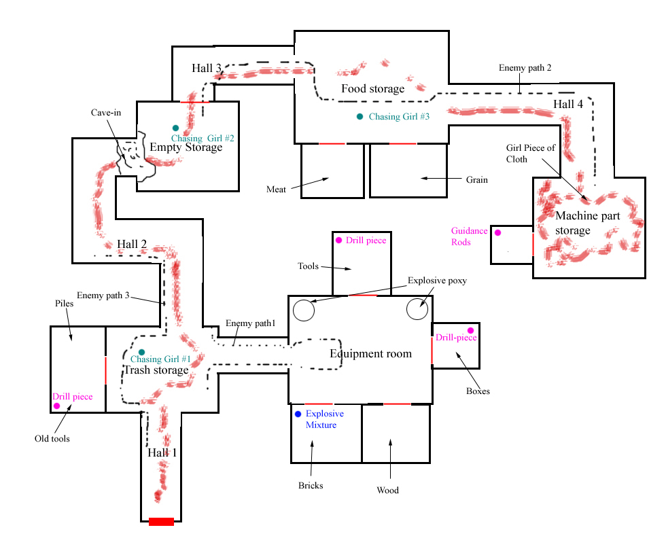

Overview
As the player enters the storage he will hear faint cries for help coming further in. There is also a trail of blood that leads the player to the right way.
In the middle of the map is a cave in. To get rid of the player must find first find parts of a hand-drill, assemble it and then use it to pour out liquid from two containers with an epoxy like explosive. When mixed these become highly explosive. The player then need to place the epoxy in front of the cave in and throw a rock at it from far away making it explode. If the player is too near he gets killed or badly hurt.
When inside the calls for help get louder and louder until the player is in a room and they suddenly stop. They player’s light goes out and then suddenly a torch lights in the middle of the room, a really loud scream is heard and the player will see the walls spattered with blood. At the back of this room the player will also find some cog wheels to be used ina puzzle.
In this map the player will also see some servants running around and will have to avoid one or two.

Items
Explosive
Hand drill. + parts
Guidance rods. 2 rods that are used in the machine room (another is in level 11).

Puzzles
Create explosive
There are two epoxy containers for an explosive that need to be mixed. First of all the taps do not work and the player need to collect all pieces of a hand-drill and make a hole. Then the player can place the container (used for acid potion) at each stream of expoxy and collect it.

Destroy cave-in
By using the explosive on the cave in the container is placed in front of the rocks. The player must then throw a rock at the container from a distance and the mixture will explode.

Visions
Chasing girl #1
The foot steps and panting from a girl is heard and a few seconds late the determined (and slower steps) of a man, Daniel, is heard. (Has large area so that player will always trigger it)

Chasing girl #2
The girl trips, falls to the ground, gaps and then continue running. The man’s footsteps are closer now. (Has large area so that player will always trigger it)

Chasing girl #3
The girl’s panic is clearly heard in her panting and he stumbles more than runs at his point. The man’s foot step come almost instantly after the girl disappears now and the sound of him drawing a knife is heard. (Has large area so that player will always trigger it)

Notes
Explosive Mixture
Briefly explains how the epoxy explosives works.

Events
Cries
The closer the player comes to machine part storage the louder cries for help from a girls gets. They are also especially loud when the cave-in is blocking and the player is near it (to give the player motivation to get past). Also, the close the player gets the cries are changed from screams for help into the girl begging for mercy.

Bloody discovery
When the before the player rounds the corner in hall 4 and heads toward machine part storage the lights go out (even lantern) and any cries stop. When the player enters the machine room storage the lights suddenly get back on, a very loud scream of pain is heard and the player will see that the walls are covered in blood. In the middle of a room is a lantern it is this that finally illuminates the room.

Enemy Encounter 1
When the player has been in Equipment room for X seconds an enemy appears and walks along path 1.

Enemy Encounter 2
When the player has created explosive and is about to enter trash storage then an enemy appears along path 3.

Enemy Encounter 3
When the player has the things needed to fix the elevator and enters Food storage an enemy appears along path 2.

Rooms
General
The level is quite gloomy and infrequent lights help illuminate at places.

Trash Storage
The room is littered with junk on the floor and along the walls old boxes are stacked. The western part is full of large piles of old food, boxes and other junk. The western part is also completely dark.

Equipment Room
Some torches on the walls help shed light on the surroundings. There are shelves lined up against walls with a few items on them. Most of the stored items are placed in the connecting rooms.

Hall 2
Littered with debris and lit up by a few torches on the walls this hall leads to the cave-in to the north.

Empty storage
A lone shelf stands in a corner and some old papers are spread out on the floor. This room is almost totally dark except for some faint light coming from hall 2 to the west.

Hall 3
The hall is in complete blackness.

Food storage
The main hall has some faint flickering torches on the walls and various stains and broken boxes on the floor. The connecting rooms contain supplies of rotten meat and old grains. There is a terrible stench here and flies swarm especially around the meat storage.

Hall 4
A grate in the ceiling shine some light here. Apart from that the hall is utmost dark.

Machine part storage
Blood is splattered an all walls, but no corpse is visible. There are flies flying around in the air and a torch in the middle illuminate the disgusting site. There are old and broken cog wheels and other rusty metal items hung on the wall. Together with the blood it gives the room an intense brown-red tone.
On the floor lies a piece of blue cloth left by the girl killed here. The cloth shall be blue and very contrasting to the environment. The same piece is found the girl's cell in in level 15 (Prison).

Level 13 – Machine Room
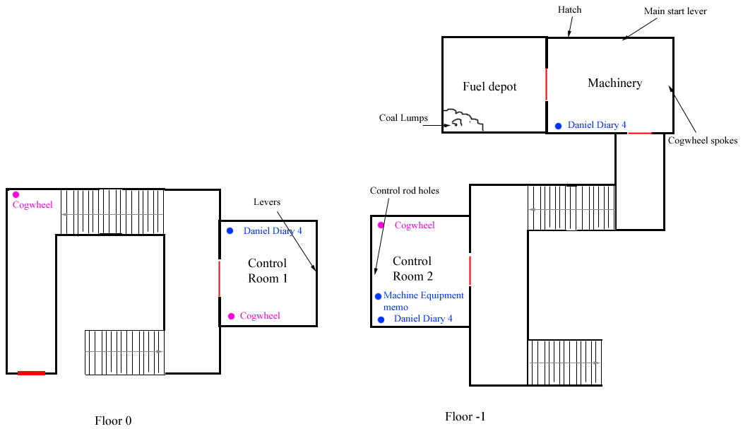

Overview
This rooms leads the player into a cellar with giant machine that makes the elevator work. Using the directions found in study and the spare parts in storage the player must get the machinery working.
To get the machine working 6 and X wheels levers must be in the correct positions (according to instructions). Three missing pieces (from storage) must also be put correctly and cogwheels from the ground put back.

Notes
Machine Equipment Memo
A note that briefly state that the one of the spare guidance rods have been brought to the study for repair. The rest are stored in the storage.

Daniel’s Diary 4
Daniels tells about the howling and of the corpses that turn up. The entries end with Daniel determining himself to go to the Alexander in Prussia.

Events
Shake n howl
When machine is ready and player goes up the stair there are 2 rumblings heard followed by a howl that seems quite near. The player should think that the guardian is very near now.

Puzzle
Fix machine
In order to fix the machine a number of sub-puzzles must be completed. These are:
- Add and ignite fuel
- Repair cogwheels
- Add guiding rods
- Turns levers (direct flow)
Once these are done there is a main switch in the machinery that needs to be turned and the machine will start running and the elevator will function.

Add and ignite fuel
In the fuel depot there is a pile of coal lumps in a corner. In the machinery there is a hatch where the lumps can be thrown in. The player needs to throw at least three lumps into the hatch chamber behind the hatch and then pull the ignition lever next to the hatch. When this is done it will start burning in the chamber. Further lumps of coals or pulls in the ignition lever will do nothing.

Repair cogwheels
Three cogwheels are scattered over the lever and needs to be put on spokes in the machinery. The cogwheels will only fit on their specific spokes and they all will connect once placed.

Add guiding rods
In the storage room three guidance rods can be found and they must be placed in specific holes in the wall in Control room 2. Above each hole is symbol and these are: Triangle, Circle and Square.
The rods are numbered 1, 2 and 3 (visible in description). 1 goes with triangle, 2 with square and 3 with circle. The explanation for this is in the machine instructions.

Turn levers
The levers start out in up state and can be changed to down too. Above and below each lever is a roman numeral. These are (above / below)
1: III / I
2: III / V
3: V / VI
4: I / V
5: II / II
6 IV / II
To complete the puzzle, the sum of the upper numerals must be 8 and the lower 8. A numeral is picked by having the lever in the corresponding state. The numbers are detailed in the machine instructions.

Rooms
General
Lots of steam and fog fill the level and there is a lot of metal on the walls and ceiling. Pipes come out from everywhere. Plenty of lights are placed but they glow the murky light and gives the level a dream feel.

Control Room 1 – 2
Pipes with levers and wheels crawl along the walls.

Machinery
Cogwheels fill the walls.

Fuel depot
There is a large pile of coal here and lots of boxes stacked. A shovel is in one corner and there is also a table with some tools.

Level 14 – Elevator ride

Overview
When the player has stepped into the elevator it starts moving down slowly, after a while the howling sound is heard and the elevator stops. The elevator will start to shake and more howling is heard. Then it will quickly fall toward the ground, crash in a cloud of smoke and the screen will fade out.

This level is only a single room showing the inside of the elevator and the player can see the wall, showing the elevator’s speed of descent.

When the descent is over, the screen is filled with dust, it fades and then the first map of chapter 2 is loaded.

